EXPERIMENT 204
VERIFICATION OF SOME NETWORK THEOREMS

Aim
Network theorems help electrical engineers to analyse electrical circuits and solve for the current and/or voltage response in any branch, often much more quickly than by direct application of Ohm's Law and Kirchhoff's Laws alone. The aim of this experiment is to verify two of these theorems by practical measurement: the Superposition Theorem, using the two-source resistance circuit of Fig. 204-1, and Thevenin's Theorem, using the resistance circuit of Fig. 204.2.

Objective
- To measure the voltage and current in each resistor of a two-source circuit, with both sources active and with each source active alone, and to verify the Superposition Theorem by algebraic summation.
- To measure the open-circuit voltage, Vo, and the equivalent (Thevenin) resistance, Ro, of a resistive network as seen from a chosen pair of terminals.
- To measure the voltage across a load resistor, RL, connected to those terminals, and to verify that this agrees with the value predicted using the Thevenin equivalent circuit.
- To understand the practical usefulness of both theorems in simplifying the analysis of linear circuits.

Theory
Many of the circuits met in electrical engineering contain more than one source of e.m.f., and analysing them directly, using only Ohm's Law and Kirchhoff's Laws, can quickly become complicated as the number of sources and components increases. Network theorems help electrical engineers to avoid this difficulty by giving shorter, more convenient methods of finding the current and/or voltage response in any branch of a circuit. The Superposition Theorem and Thevenin's Theorem are two such theorems, and this experiment sets out to confirm, by direct measurement, that both hold true in practice.
The Superposition Theorem states that, in any linear circuit containing more than one independent source, the current through, or the voltage across, any element of the circuit is equal to the algebraic sum of the currents or voltages produced by each source acting alone, with all the other independent sources replaced by their internal resistance (an ideal voltage source is replaced by a short circuit, and an ideal current source by an open circuit). In this experiment, the circuit contains two d.c. voltage sources, E1 and E2, together with three resistors, R1, R2, and R3. The voltage across, and the current through, each resistor is first measured with both sources connected; then E1 is removed (its terminals short-circuited) and the same quantities are measured with only E2 acting; then E2 is removed and E1 reconnected, and the measurements are repeated with only E1 acting. Because voltage and current are directed (vector-like) quantities, a reading that comes out in the opposite direction to the original reference direction is recorded as a negative value. If the theorem holds, the reading taken with both sources active should equal the algebraic sum of the two readings taken with each source acting alone.
Thevenin's Theorem states that, with respect to any pair of terminals, a linear network containing one or more e.m.f. sources can be replaced by a single equivalent voltage source, of value equal to the open-circuit voltage, Vo, measured across those terminals, in series with a single equivalent resistance, Ro, equal to the resistance measured across the same terminals when every e.m.f. source in the network has been replaced by its internal resistance. In this experiment, the pair of terminals chosen is C-D, and the circuit facing those terminals contains the source E1 together with resistors R1, R2, and R3. The open-circuit voltage, Vo, is measured directly across C-D with no load connected; the equivalent resistance, Ro, is found by disconnecting E1, short-circuiting the terminals where it was connected, and then measuring the resistance across C-D directly with the AVO-meter. Once Vo and Ro are known, the original network can be replaced, for the purpose of calculation, by the simple equivalent circuit of Fig. 204.3: a single source, Vo, in series with a single resistor, Ro. If a load resistor, RL, is then connected across C-D, the voltage across it should be given by VRL = Vo x RL / (Ro + RL), and the theorem is verified if this calculated value agrees with the value actually measured across RL in the original circuit.
Both theorems rely on the circuit being linear, which is why decade resistance boxes (whose resistance does not change with current) and stable d.c. voltage sources are used throughout this experiment. Being able to reduce a complicated network to a single equivalent source and resistance, as Thevenin's Theorem allows, is especially useful in practice, since it means the effect of connecting different loads to the same pair of terminals can be worked out quickly, without having to re-analyse the whole original circuit every time.

Method 1: Verification of the Superposition Theorem

Apparatus
- Two D.C. Voltage Sources, E1 and E2 (2)
- Three Decade Resistance Boxes, R1, R2, and R3 (3)
- AVO-meter (Multimeter) (1)
- Connecting Leads

Diagram

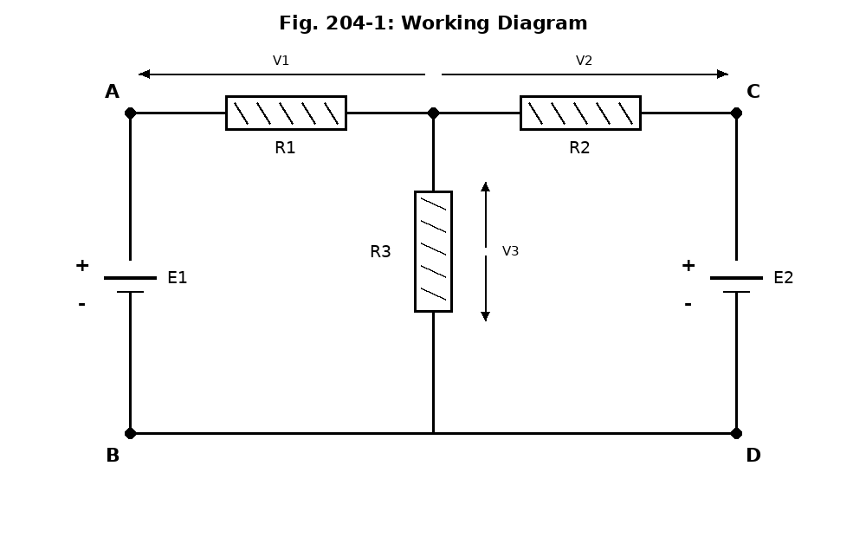

Procedure
- Connect the mains to the d.c. voltage sources E1 and E2 and switch on; using the voltage adjust controls, set the out-of-circuit output voltage of both E1 and E2 to 6 V.
- Switch off the mains to the d.c. sources, then connect the decade resistors R1, R2, and R3 and the d.c. sources as shown in the circuit diagram, noting the polarities of the sources; select a set of resistance values between 10 and 100 Ohm for R1, R2, and R3 (30 Ohm was used for each in this experiment), and have the connections checked by a supervisor.
- Switch on the mains again, and re-measure the in-circuit e.m.f. across the terminals of E1 and E2.
- With both sources connected, measure the voltage across R1, R2, and R3, recording them as V1, V2, and V3, noting the direction of each as the positive reference direction for later readings.
- Disconnect E1 from the circuit and short-circuit the terminals where it was connected; measure the voltages across R1, R2, and R3 again, recording any reading that has reversed direction as a negative value.
- Reconnect E1, then disconnect E2 and short-circuit the terminals where it was connected; measure the voltages across R1, R2, and R3 once more.
- Switch off the mains supply to both sources, calculate the current through each resistor at each stage (I = V/R), and complete Table 204.1; check whether the reading taken with both sources active equals the algebraic sum of the two readings taken with each source acting alone.

Observation
E.m.f. of Cells (Out-of-circuit and In-circuit Values)
 | E1 (V) | E2 (V)
Out-of-circuit | 6.0 | 6.0
In-circuit | 5.9 | 5.9

Table 204.1 — Superposition Theorem Readings (R1 = R2 = R3 = 30 Ohm)
Circuit Condition | V1 (V) | V2 (V) | V3 (V) | I1 (mA) | I2 (mA) | I3 (mA)
(a) E1 & E2 | -2.0 | 2.0 | -4.0 | -66.7 | 66.7 | -133.3
(b) E2 Alone | 2.0 | 4.0 | -2.0 | 66.7 | 133.3 | -66.7
(c) E1 Alone | -4.0 | -2.0 | -2.0 | -133.3 | -66.7 | -66.7
Sum (b) + (c) | 2.0 | 2.0 | 4.0 | -66.6 | 66.6 | -133.4
Sample calculation: with both sources active, I1 = V1 / R1 = 2.0 / 30 = 0.0667 A = 66.7 mA. With E2 alone, the current in R1 flows in the reverse direction, so V1 = -2.0 V and I1 = -66.7 mA.

Verifying the Theorem by Algebraic Summation
To verify the Superposition Theorem, the readings taken with each source acting alone (rows (b) and (c)) were added together and compared with the readings taken with both sources acting together (row (a)), for both the voltage response and the current response, as shown below.
Check | Left-hand side | Right-hand side
(i) V1(a) = V1(b) + V1(c) | V1(a) = -2.0 V | V1(b)+V1(c) = 2.0 + -4.0 = -2.0 V
(ii) V2(a) = V2(b) + V2(c) | V2(a) = 2.0 V | V2(b)+V2(c) = 4.0 + (-2.0) = 2.0 V
(iii) V3(a) = V3(b) + V3(c) | V3(a) = -4.0 V | V3(b)+V3(c) = -2.0 + -2.0 = 4.0 V
(i) I1(a) = I1(b) + I1(c) | I1(a) = -66.7 mA | I1(b)+I1(c) = 66.7 + (-133.3) = -66.6 mA
(ii) I2(a) = I2(b) + I2(c) | I2(a) = 66.7 mA | I2(b)+I2(c) = 133.3 + (-66.7) = 66.6 mA
(iii) I3(a) = I3(b) + I3(c) | I3(a) = -133.3 mA | I3(b)+I3(c) = -66.7 - 66.7 = -133.4 mA
Explain: All six checks above are satisfied, since the reading taken with both sources active is equal, in every case, to the algebraic sum of the two readings taken with each source acting alone. The Superposition Theorem is therefore verified for this circuit. In a real laboratory measurement, the two sides of each check may not agree exactly, even though the theorem is true; small differences of this kind are normal and are usually caused by the limited accuracy of the decade resistance boxes, small errors in reading the AVO-meter, the sources not being perfectly ideal (having a small internal resistance of their own), and the natural rounding of readings to the nearest scale division. Such small differences do not mean the theorem has failed; the theorem would only appear not to be satisfied if the two sides differed by an amount much larger than these normal sources of experimental error.

Method 2: Verification of Thevenin's Theorem

Apparatus
- One D.C. Voltage Source, E1 (1)
- Three Decade Resistance Boxes, R1, R2, and R3 (3)
- One Decade Resistance Box used as the load, RL (1)
- AVO-meter (Multimeter) (1)
- Connecting Leads

Diagram
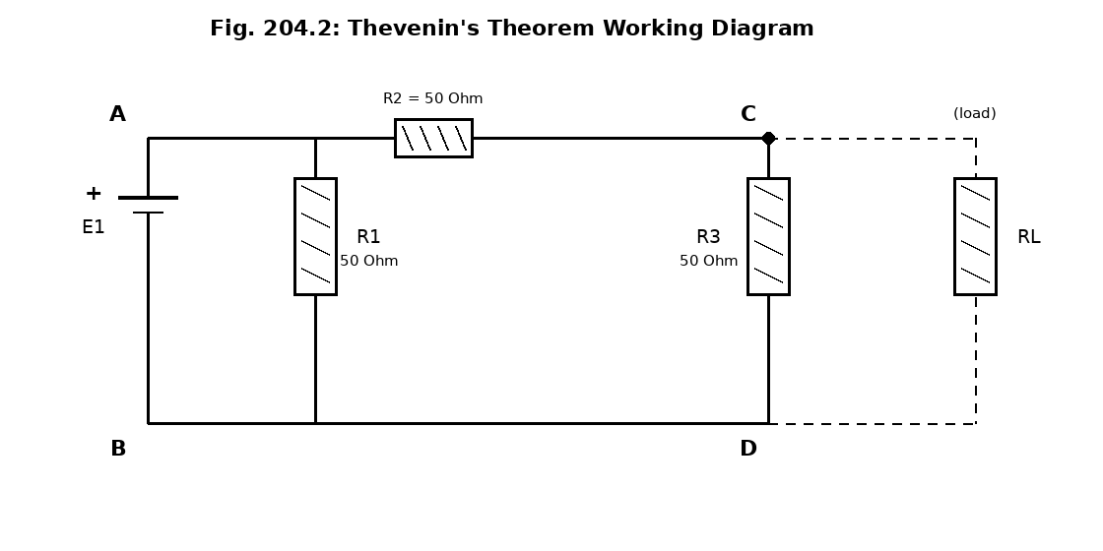
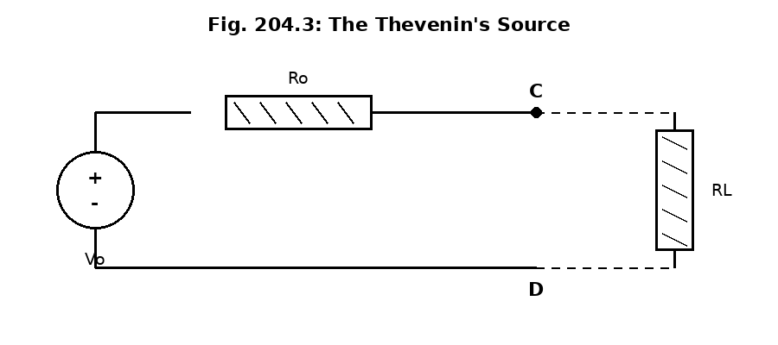

5.3 Procedure
- Connect the decade resistances R1, R2, and R3 and the d.c. voltage source E1 as shown in the circuit diagram, Fig. 204.2, using only source E1 for this experiment.
- Set each of the decade resistances to 50 Ohm and connect the mains to the d.c. power source E1.
- Switch on the mains to E1 and adjust its output voltage to read 6 V.
- Measure the potential difference across terminals C-D and record it; this is the open-circuit voltage, Vo.
- Set a load resistor, RL, to a value between 1 and 100 Ohm, connect it across terminals C-D, and re-measure the potential difference, VRL, across C-D; record this value.
- Disconnect RL from terminals C-D, then disconnect the leads from the output of source E1 and short-circuit the terminals where it was connected, sketching the resultant circuit (Fig. 204.4).
- Set the AVO-meter to measure resistance (lowest range) and measure the resistance across terminals C-D; this is the equivalent (Thevenin) resistance, Ro.
- Fill in Table 204.2 with the values of Vo, Ro, RL, and VRL, and verify Thevenin's Theorem by checking whether VRL / RL is equal to Vo / (Ro + RL).

Observation
Table 204.2 — Thevenin's Theorem Readings (R1 = R2 = R3 = 50 Ohm)
e.m.f. E1 (V) | RL (Ohm) | Ro (Ohm) | Vo (V) | VRL (V)
6.0 | 25 | 25 | 3.0 | 1.5
Equivalent resistance calculation: with E1 short-circuited, R1 is short-circuited out of the circuit, leaving R2 and R3 in parallel across C-D: Ro = (R2 x R3) / (R2 + R3) = (50 x 50) / 100 = 25 Ohm, which agrees with the value measured directly with the AVO-meter.
Thevenin's Theorem verified: VRL / RL = 1.5 / 25 = 0.06. Vo / (Ro + RL) = 3.0 / (25 + 25) = 3.0 / 50 = 0.06. Since both sides are equal, Thevenin's Theorem is verified for this circuit.

Precaution
- All connections were checked by a supervisor before the power supply was switched on, as instructed.
- The polarities of the d.c. sources were carefully noted and connected correctly, since a reversed source would give wrong readings and could damage the meters.
- The AVO-meter was set to the correct range (0-10 V for voltage measurements, and the lowest range for resistance measurements) before each reading was taken.
- When short-circuiting a source's terminals to remove it from the circuit, care was taken to short-circuit only the intended terminals, and not any other part of the circuit.
- The direction (sign) of every voltage and current reading was carefully noted and recorded, since this was essential for correctly verifying the Superposition Theorem.
- The resistance across terminals C-D was measured only after the source E1 had been completely disconnected from the circuit, to avoid damaging the AVO-meter's resistance range.
- All mains supplies were switched off immediately after each part of the experiment was completed.

Conclusion
This experiment successfully verified both the Superposition Theorem and Thevenin's Theorem using simple resistive circuits. In the first part, the voltage and current in each resistor, measured with both sources acting together, were found to equal the algebraic sum of the readings taken with each source acting alone, confirming the Superposition Theorem. In the second part, the equivalent resistance, Ro, calculated from the circuit and measured directly with the AVO-meter, agreed with each other, and the voltage across the load resistor, calculated using the Thevenin equivalent circuit, agreed with the voltage actually measured in the original circuit, confirming Thevenin's Theorem. Overall, the experiment showed that both theorems give an accurate and reliable way of analysing linear circuits with multiple sources or complex networks, and that Thevenin's Theorem in particular offers a convenient shortcut for predicting how a circuit will behave with different loads, without needing to re-analyse the whole circuit each time.

